# Instruction Sheet

Hi, dear volunteer

First of all, thanks so much for your interest and cooperation in participating this experiment. The experiment is conducted by Peng-fei Li (Vincent), an honor student from the Department of Computer Science. If you have any problems related to this project, don’t hesitate to contact me ([u4959060@anu.edu.au](mailto:u4959060@anu.edu.au)) or my supervisors Professor David Hawking (David.Hawking@funnelback.com) and Paul Thomas ([paul.thomas@csiro.au](mailto:paul.thomas@csiro.au)).

## What are we doing?

We are now developing a search engine that combine all the results retrieved by different search engines across ANU. The current issue about the project is to evaluate the efficiency of the search engine to see if it works properly and whether it can output comfortable results to users. So as a nature of search engine, it should give as many relevant documents as possible in the top results and more relevant document should rank high in the result lists. Now what you are doing is to judge if a document is relevant to a query and how much is the relevance. By the relevance score that produced by you, we can then apply them to some other methods to test if the search engine work well.

## How to do it?

The process of the experiment is quite easy, so take it easy. All you need is a computer with a web browser (I also recommend if you got an IE, I prefer you to update it to version higher and 7.0). Then follow the following steps, you can judge the documents.

***Step1:***

Open your web browser and type in *http://djudge.com/assess/* in the url address, you’ll see you client ID in the first page, do not bother with it, it’s just a record assigned by the system. Then you click on the “start” button to begin the judgment.

***Step2:***

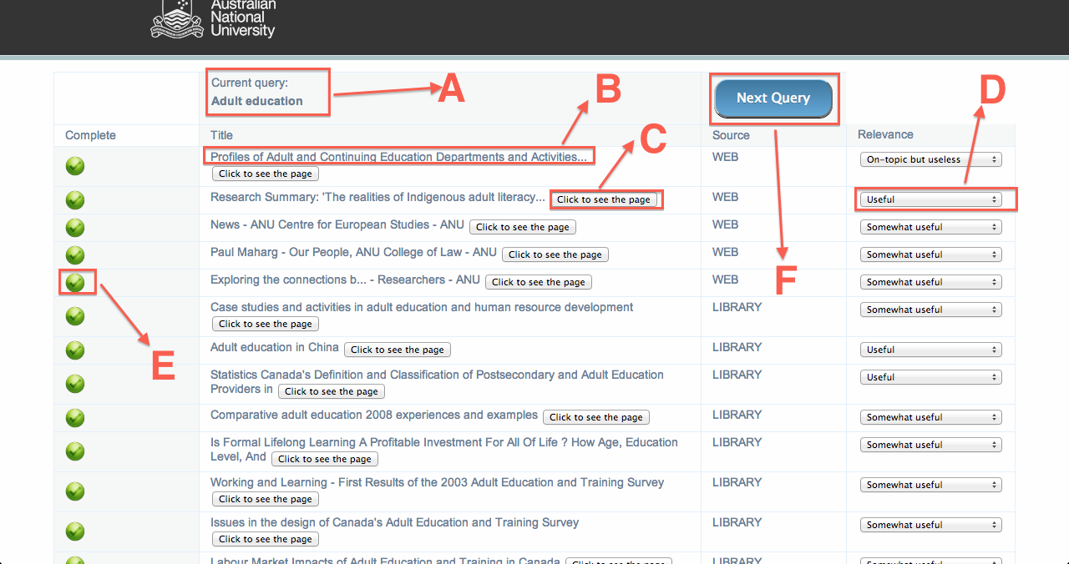

Picture 1

Now you’ll see a page with a query and documents as displayed in picture 1. The query term is displayed in part A, and the title of each document is displayed in part B, you can view the original page of the document click the button “click to see the page”, which is part C in the picture, and please make sure you have viewed the document before score it.

***Step3:***

The part D is a button that you can assign the relevance score to the document, if you think the document is totally irrelevant to the query, select “Non-Relevant” and choose other relevance according to your judge.

***Step4:***

After you finish all the judgments on a query, you can choose to judge another query by click the button “Next Query”, which is part F. Notice that you can never judge another query before you judged all the documents to a query. You can check the completeness of your judgment by part E.

You can follow the above steps to judge 2 to 3 queries for us and we will be so appreciate if you can do more!!

## What if you want to terminate?

If you feel any uncomfortable about the experiment, you can terminate the experiment by close the web browser. And at any time you want to continue the judgment, you can open the browser again and continue with the previous procedure and please make sure you use the same web browser when you continue the experiment.

And at last, so appreciate for you involvement and hope you all good through out the experiment!

Regards,

Vincent Li.